**Title of the experiment**

Experiment 7

consider the schema for college database and draw and er diagram.

student (usn, sname, address, phone, gender) semsec (ssid, sem, sec)

class (usn, ssid) subject (subcode, title, sem, credits) iamarks (usn, subcode, ssid, test1, test2, test3, finalia)

write sql queries to

1. list all the student details studying in fourth semester ‘c’ section.

2. compute the total number of male and female students in each semester and in each section.

3. create a view of test1 marks of student usn ‘1bi15cs101’ in allsubjects.

4. calculate the finalia (average of best two test marks) and update the corresponding table for all students.

5. categorize students based on the followingcriterion: if finalia = 17 to 20 then cat =‘outstanding’ if finalia = 12 to 16 then cat = ‘average’ if finalia< 12 then cat = ‘weak’

give these details only for 8th semester a, b, and c section students.

**CREATION OF COLLEGE DATABASE:**

**SYNTAX:**

create database college;

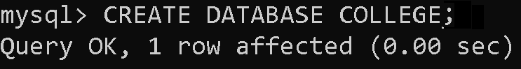

**SYNTAX:**

**DISPLAY DATABASES:**

show databases;

**OUTPUT:**

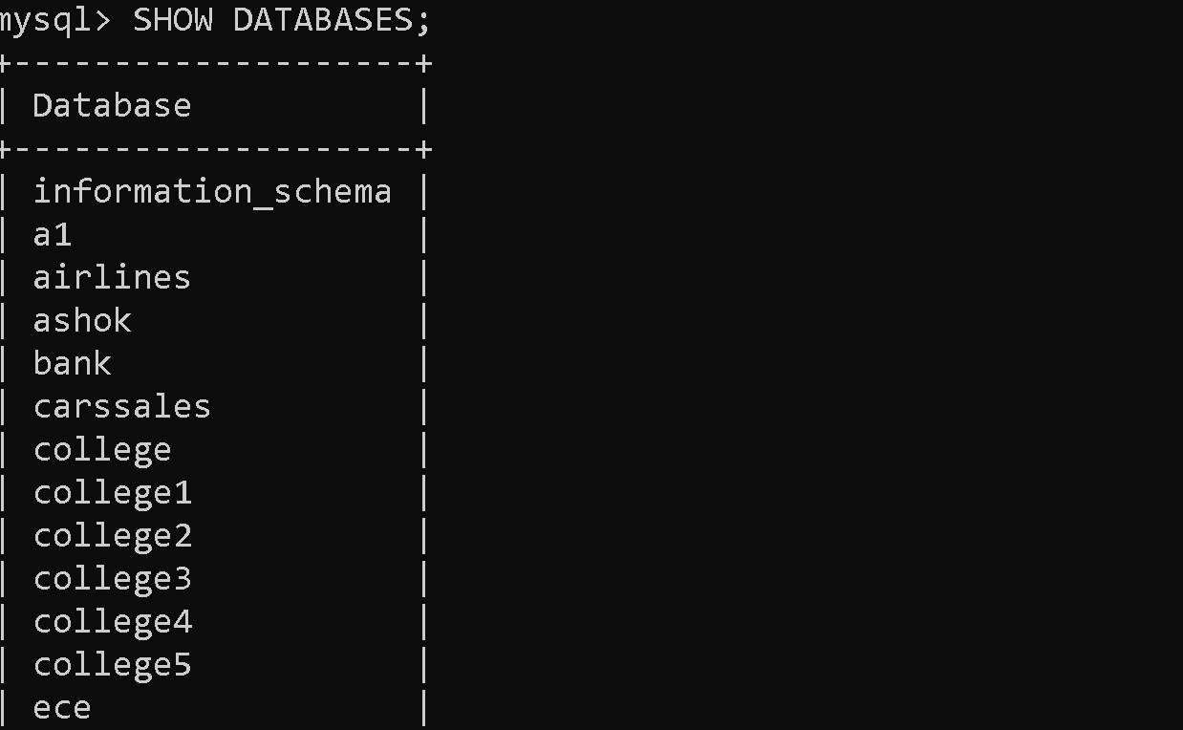

**SWITCH OVER TO DATABASE CREATED :**

**SYNTAX:**

use college;

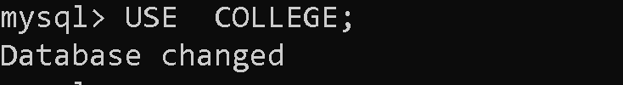

**CREATION OF TABLES IN COLLEGE DATABASE:**

**CREATE TABLE FOR STUDENT:**

**SYNTAX:**

create table student(usn char(10),sname varchar(20),address varchar(25), phone int(10),gender char,constraint a primary key(usn));

**OUTPUT:**

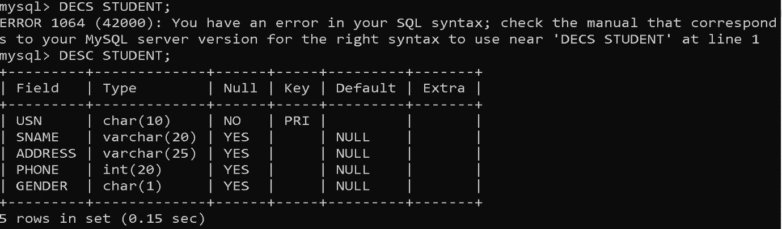

**CREATE TABLE FOR SEMSEC:**

**SYNTAX:**

create table semsec(ssid char(2),sem int(1),sec char,constraint b primary key(ssid),constraint c check(sem between 1 and 8));

**OUTPUT:**

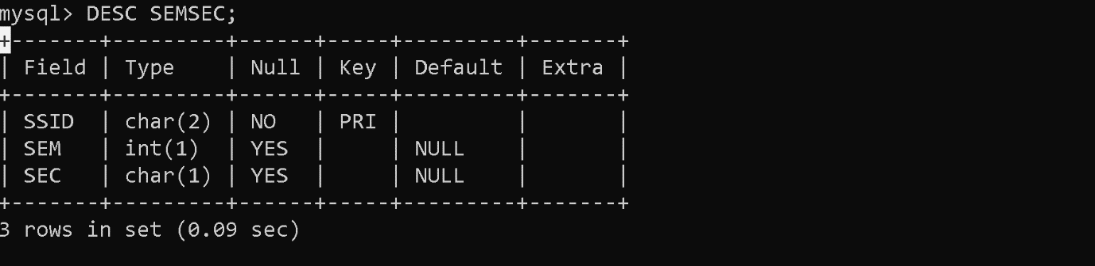

**CREATE TABLE FOR CLASS:**

**SYNTAX:**

create table class(usn char(10),ssid char(2),constraint d primary key(usn,ssid),constraint e foreign key(usn) references student(usn) on delete cascade,constraint f foreign key(ssid) references semsec(ssid) on delete cascade);

**OUTPUT:**

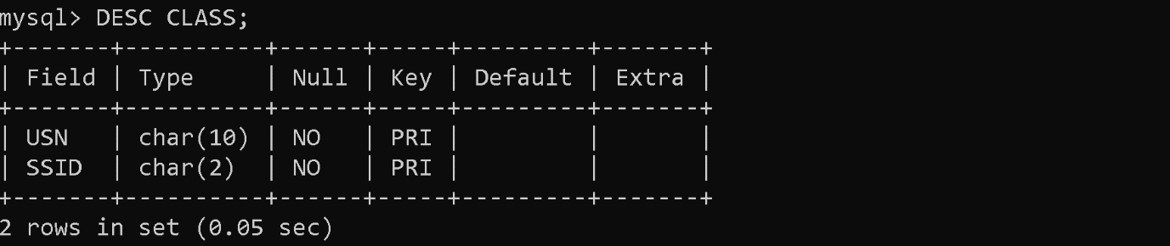

**CREATE TABLE FOR SUBJECT:**

**SYNTAX:**

create table subject(subcode varchar(7),title varchar(20),sem int(1),

credits int(1),constraint g primary key(subcode));

**OUTPUT:**

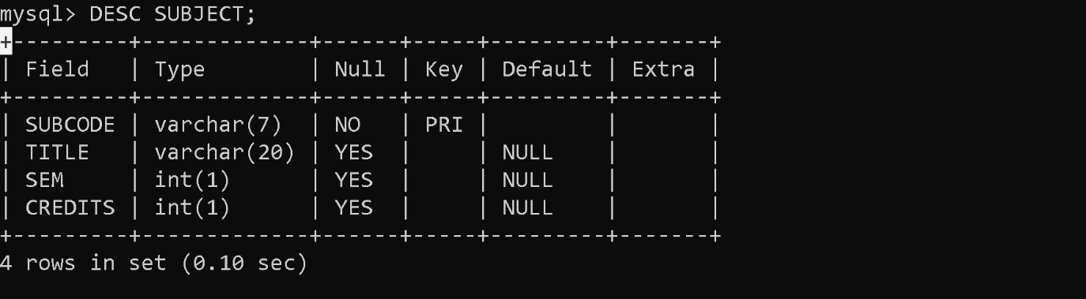

**CREATE TABLE FOR IAMARKS:**

**SYNTAX:**

create table iamarks(usn char(10),subcode varchar(7),ssid char(2), test1 int(2),test2 int(2),test3 int(2),finalia int(2), constraint h primary key(usn,subcode,ssid), constraint i foreign key(usn) references student(usn) on delete cascade,constraint j foreign key(ssid) references semsec(ssid) on delete cascade,constraint k foreign key(subcode) references subject(subcode) on delete cascade);

**OUTPUT:**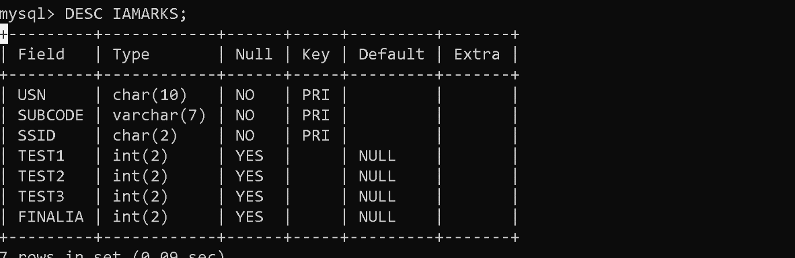

**INSERTION OF DATA FOR COLLEGE DATABASE:**

**INSERT VALUES INTO STUDENT TABLE:**

**SYNTAX:**

insert into student (usn,sname,address,phone,gender) values

(“1mv17cs001”, “aashish”, “bangalore”,1020304050, “m”),

(“1mv17cs060”, “naela”, “mysore”,1122334455, “f”),

(“1mv17cs130”, “milind”, “jammu”,506070809, “m”),

(“1mv16cs001”, “abhijith”, “pune”,998877655, “m”),

(“1mv16cs060”, “nikitha”, “hyderabad”,900706050, “f”),

(“1mv16cs130”, “sanjana”, “guwahatti”,124567890, “f”),

(“1mv15cs001”, “anshuman”, “panaji”,111223334, “m”),

(“1mv15cs060”, “amrutha”, “bangalore”,102003004, “f”),

(“1mv15cs130”, “bhuvanesh”, “jaipur”,900007006, “m”),

(“1mv14cs001”, “devayani”, “bangalore”,1020030, “f”),

(“1mv14cs060”, “david”, “kochi”,90080070, “m”),

(“1mv14cs130”, “aishwarya”, “mumbai”,100020000, “f”);

**OUTPUT:**

select * from student;

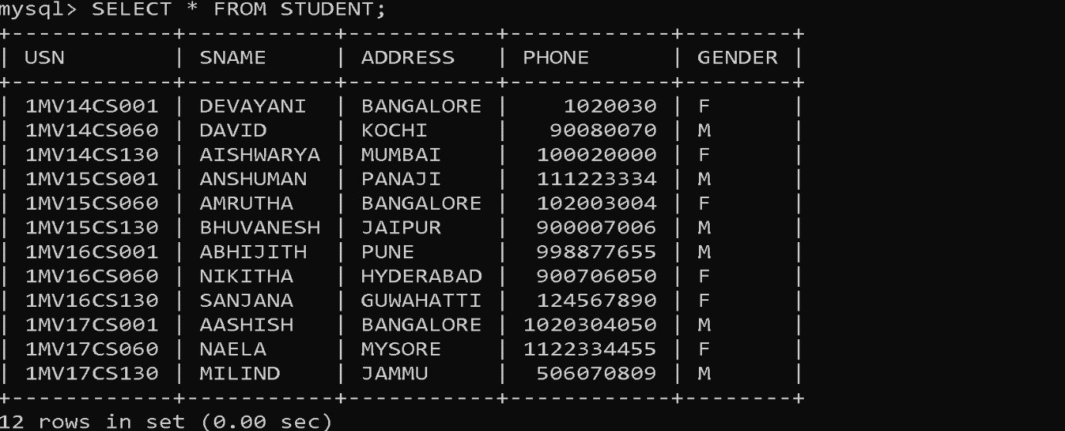

**INSERT VALUES INTO SEMSEC TABLE:**

**SYNTAX:**

insert into semsec (ssid,sem,sec) values

(“2a”,2, “a”),(“2b”,2, “b”),(“2c”,2, “c”),(“4a”,4, “a”),(“4b”,4, “b”),(“4c”,4, “c”),

(“6a”,6, “a”),(“6b”,6, “b”),(“6c”,6, “c”),(“8a”,8, “a”),(“8b”,8, “b”),(“8c”,8, “c”);

**OUTPUT:**

select * from semsec;

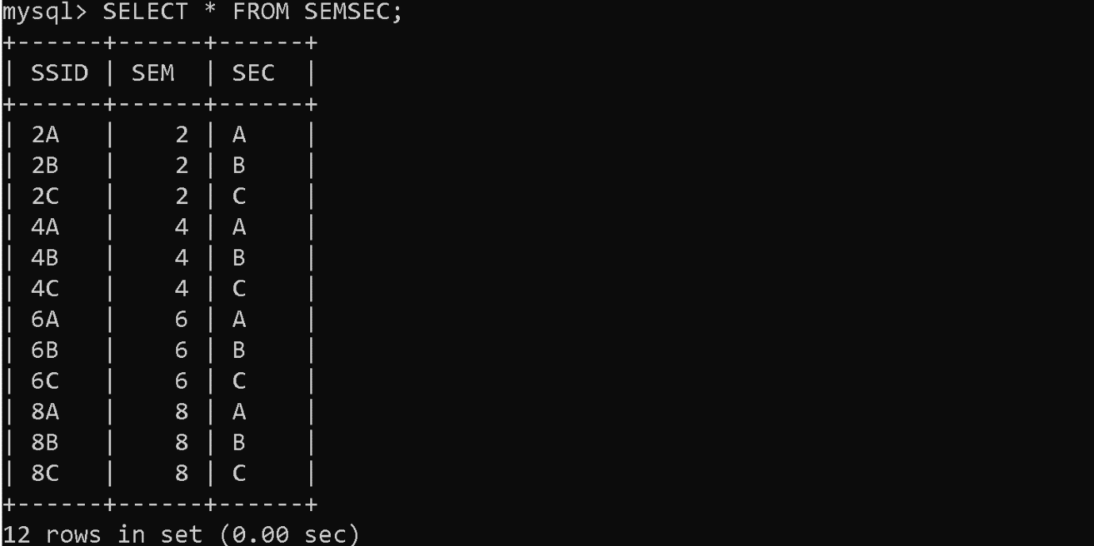

**INSERT VALUES INTO CLASS TABLE:**

insert into class(usn,ssid) values

(“1mv17cs001”, “2a”),

(“1mv17cs060”, “2b”),

(“1mv17cs130”, “2c”),

(“1mv16cs001”, “4a”),

(“1mv16cs060”, “4b”),

(“1mv16cs130”, “4c”),

(“1mv15cs001”, “6a”),

(“1mv15cs060”, “6b”),

(“1mv15cs130”, “6c”),

(“1mv14cs001”, “8a”),

(“1mv14cs060”, “8b”),

(“1mv14cs130”, “8c”);

**OUTPUT:**

select * from class;

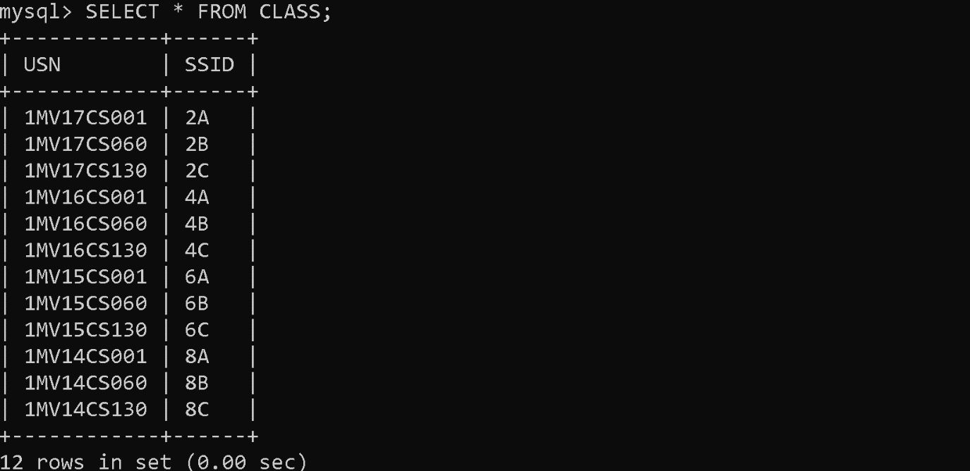

**INSERT VALUES INTO SUBJECT TABLE:**

**SYNTAX:**

insert into subject(subcode,title,sem,credits) values

(“15cs21”, “m2”,2,4),

(“15pcd23”, “pcd”,2,4),

(“15cs42”, “se”,4,4),

(“15cs44”, “mp”,4,4),

(“15cs64”, “cg”,6,4),

(“15cs62”, “usp”,6,4),

(“10cs81”, “sa”,8,4),

(“10cs842”, “st”,8,3);

**OUTPUT:**

select * from subject;

**INSERT VALUES INTO IAMARKS TABLE:**

insert into iamarks(usn,subcode,ssid,test1,test2,test3) values

(“1mv17cs001”, “15cs21”, “2a”,15,14,13),

(“1mv17cs060”, “15pcd23”, “2b”,15,15,14),

(“1mv17cs130”, “15cs21”, “2c”,11,12,13),

(“1mv16cs001”, “15cs42”, “4a”,19,19,18),

(“1mv16cs060”, “15cs44”, “4b”,5,8,5),

(“1mv16cs130”, “15cs42”, “4c”,20,20,20),

(“1mv15cs001”, “15cs64”, “6a”,12,12,12),

(“1mv15cs060”, “15cs62”, “6b”,18,19,20),

(“1mv15cs130”, “15cs64”, “6c”,8,12,11),

(“1mv14cs001”, “10cs81”, “8a”,3,11,12),

(“1mv14cs060”, “10cs842”, “8b”,0,0,7),

(“1mv14cs130”, “10cs81”, “8c”,0,0,20);

**OUTPUT:**

select * from iamarks;

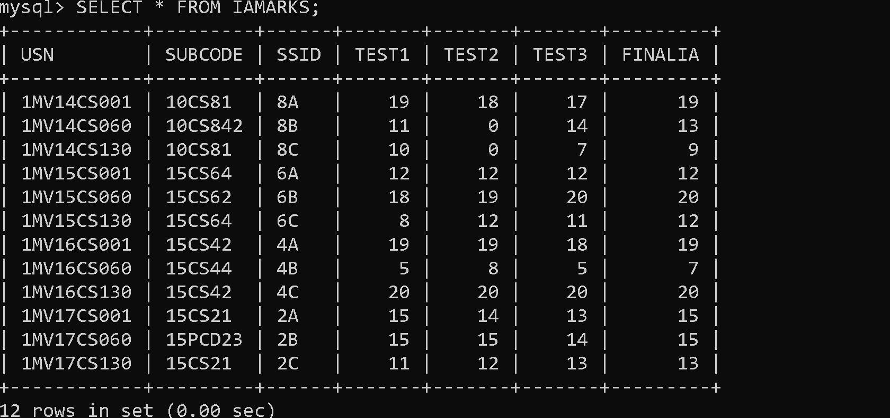

**QUERIES:**

1. **MAKE A LIST OF ALL STUDENTS DETAILS STUDYING IN 4TH SEM C-SEC**

**SYNTAX:**

select s.usn,s.sname,s.address,s.phone,s.gender from student s,class c,semsec ss where s.usn=c.usn and ss.ssid=c.ssid and ss.sem=4 and ss.sec='c';

**OUTPUT:**

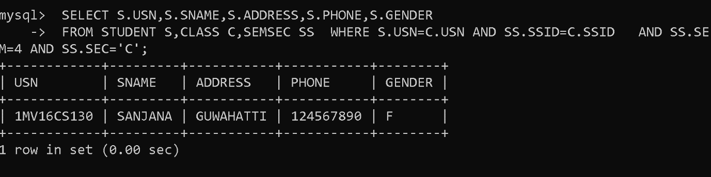

2. **COMPUTE THE TOTAL NO.OF MALE AND FEMALE STUDENTS IN EACH SEMESTER AND IN EACH SEC**

**SYNTAX:**

select ss.sem,ss.sec,s.gender,count(s.gender) from student s, semsec ss, class c where

s.usn=c.usn and ss.ssid=c.ssid group by ss.sem, ss.sec, s.gender;

**OUTPUT:**

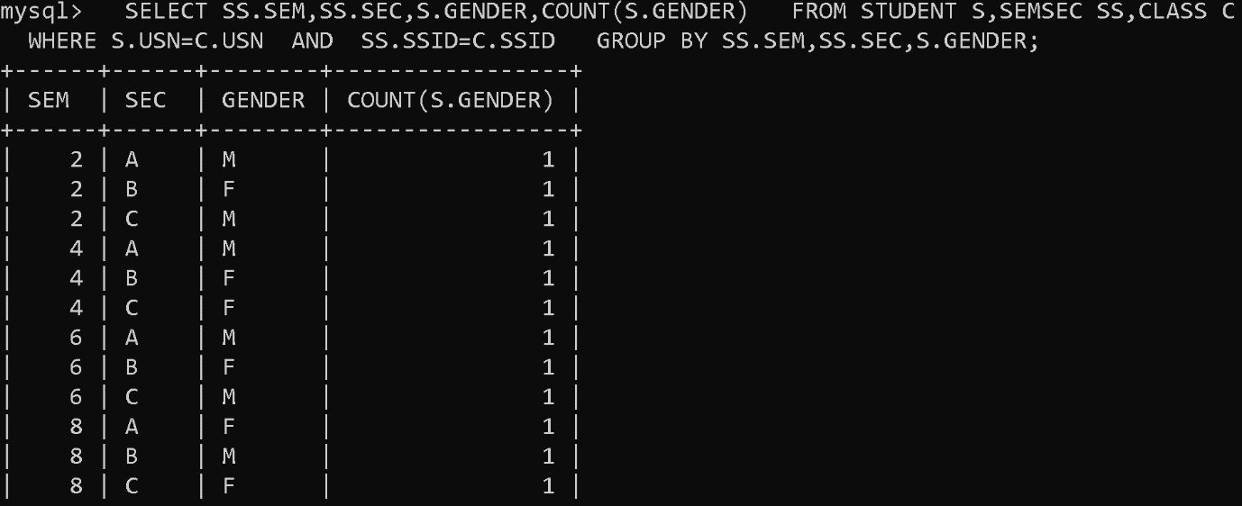

3. **CREATE VIEW OF TEST1 MARKS OF STUDENT 1MV15CS060 IN ALL SUBJECTS**

**SYNTAX:**

create view test1_marks as select usn,subcode,test1 from iamarks where usn='1mv15cs060';

view created

**OUTPUT:**

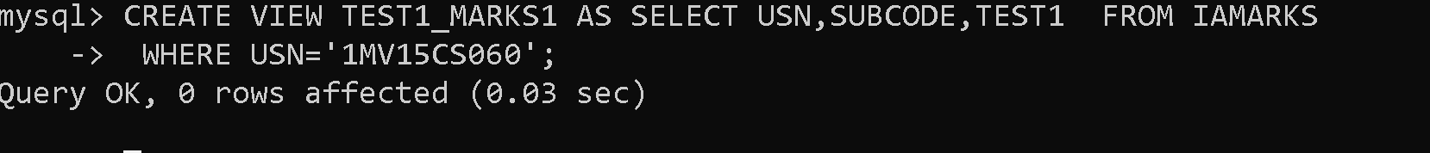

**SYNTAX:**

select * from test1_marks;

**OUTPUT:**

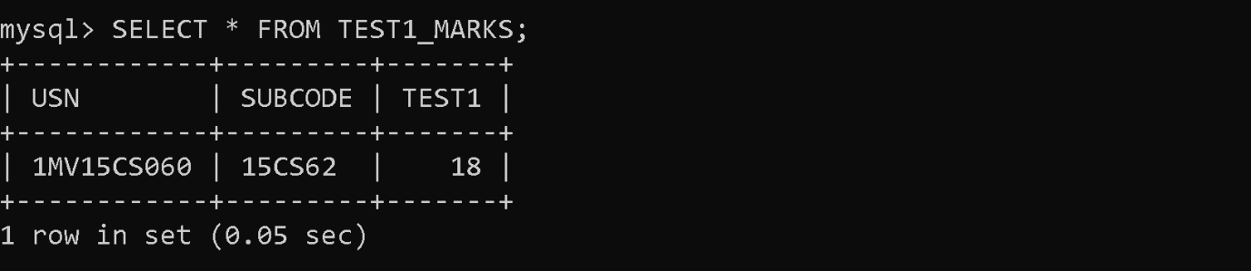

**UPDATE VALUES IN IAMARKS TABLE:**

**SYNTAX:**

update iamarks set test1=19,test2=18,test3=17 where usn='1mv14cs001';

**SYNTAX:**

update iamarks set test1=11,test2=0,test3=14 where usn='1mv14cs060';

**SYNTAX:**

update iamarks set test1=10,test2=0,test3=7 where usn='1mv14cs130';

**DISPLAY THE IAMARKS TABLE:**

**SYNTAX:**

select * from iamarks;

**OUTPUT:**

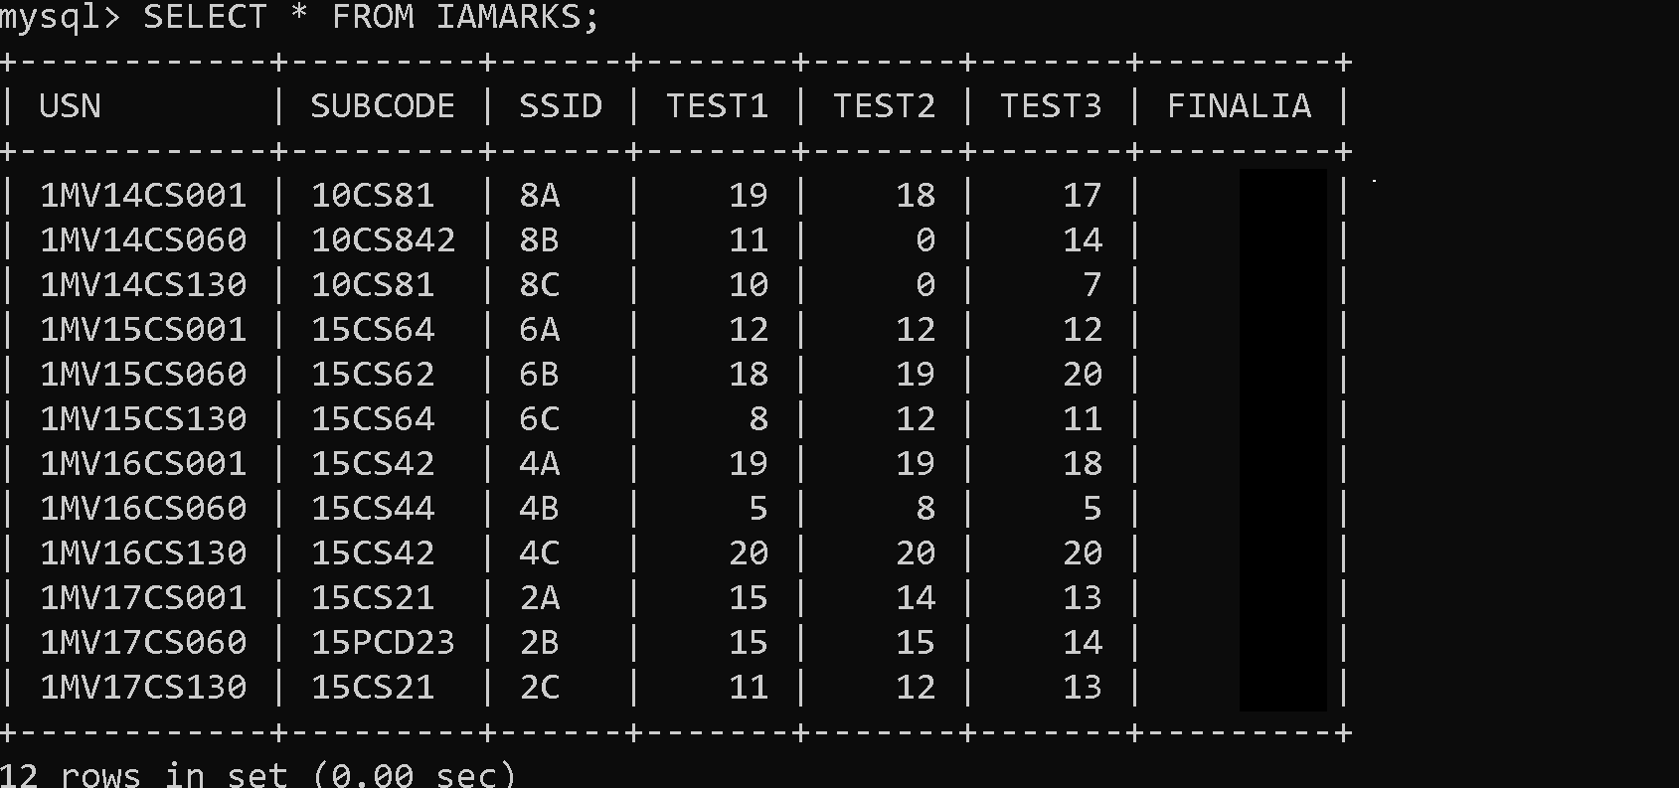

4. **CALCULATE THE FINAL IA MARKS AND UPDATE THE CORRESPONDING TABLE FOR ALL STUDENTS**

**SYNTAX:**

update iamarks set finalia=(greatest (test1+test2,test2+test3, test3+test1)/2);

**SYNTAX:**

Select * from iamarks;

**OUTPUT:**

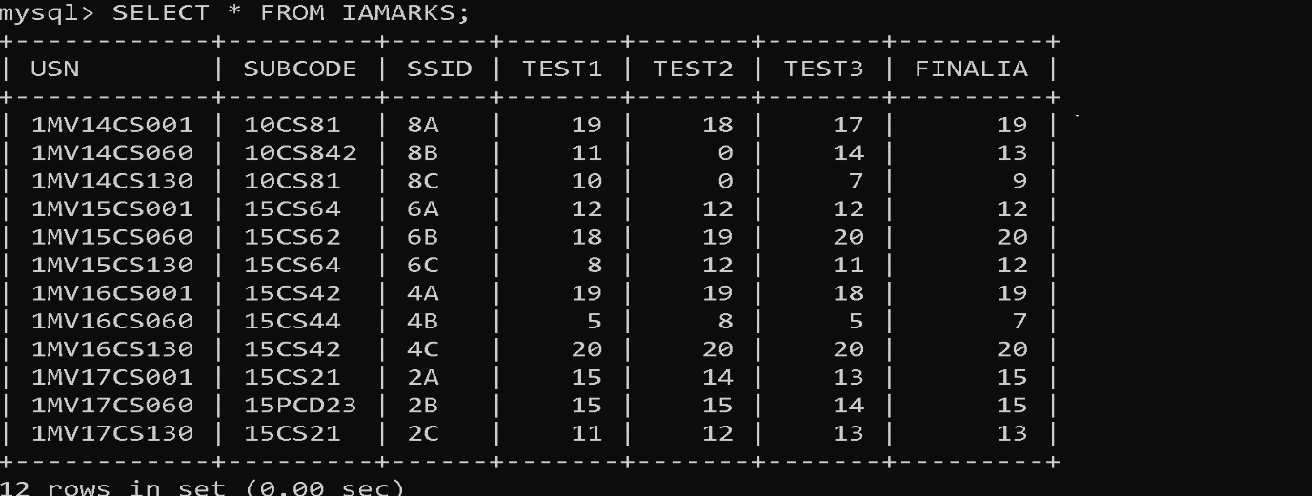

5. a)**CATEGORISE STUDENTS BASED ON THE FOLLOWING CRITERIA:**

if finalia=17 to 20 then cat=’outstanding’

if finalia=12 to 16 then cat=’average’

if finalia=00 to 11 then cat=’weak’

give these details only for 8th semester a, b and c section students.

**SYNTAX:**

select s.usn,s.sname,s.address,s.phone,s.gender,

(

case

when ia.finalia between 17 and 20

then 'outstanding'

when ia.finalia between 12 and 16

then 'average'

else 'weak'

end

)

as cat from student s,semsec ss,iamarks ia where s.usn=ia.usn and ss.ssid=ia.ssid and

ss.sem=8;

**OUTPUT:**

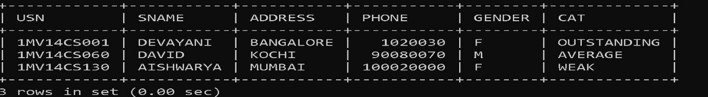

5. b)**UPDATE IAMARKS SET FINALIA=NULL;**

**SYNTAX:**

update iamarks set finalia=null;

**SYNTAX:**

select * from iamarks;

**OUTPUT:**

